Exercises: Django Models Basics
Submit your solutions to the SoftUni Judge system.
Ask your questions here: https://www.slido.com by entering the course code #python-db

Person
Write a Django model called "Person" which stores information about their name and age:
- name
- Character field.
- Every name has a length with a maximum of 30 characters.
- age
- Positive integer field.

Hint:
First, let us open and configure the Ready-to-use Skeleton. After all the packages are installed, we need to start to write the model in our application - "main_app". To begin with, we need to ensure that the virtual environment is turned on. We can turn it on with the command: "venv\Scripts\activate".
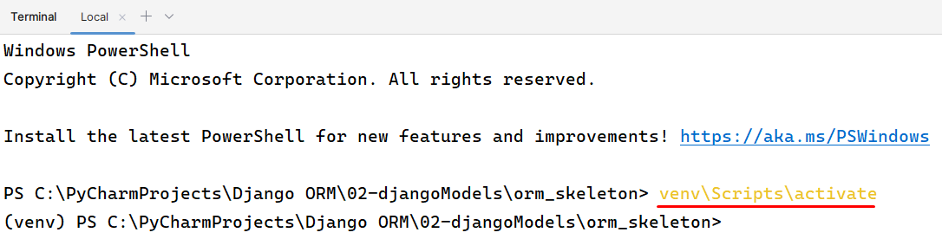
Once our virtual environment is ready, we proceed to install the required dependencies listed in the requirements.txt file. This is accomplished by entering the command "py -m pip install -r requirements.txt" in the terminal:
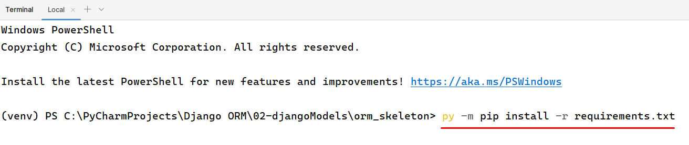
Now, let us open the "models.py" file in the "main_app" application, where we will define our model. First, we create a class called "Person" which subclasses the built-in Django "models.Model" class. In Django, a model represents a database table, where each attribute of the model maps to a column in that table.
Consequently, when you create an instance of the "Person" class, it will be saved as a record/entity (a row) within the database:
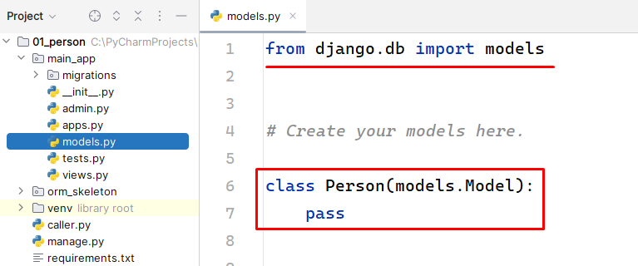
Next, let us define the "name" attribute and assign it an instance of the "models.CharField" class. This field corresponds to a varchar column in the database table and is responsible for storing the person's name.
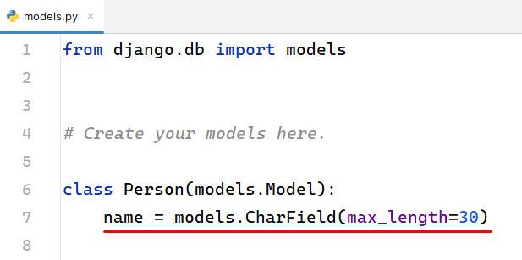
Note: when defining the field, it is necessary to specify the maximum length of this field using the "max_length" parameter.
Finally, let us define the attribute called "age" and assign it an instance of the "models.PositiveIntegerField" class. This field corresponds to an integer column with a constraint that it should only accept positive values and is responsible for storing the person's age.
Note: unlike the "CharField", there are no mandatory parameters that need to be specified for this field:
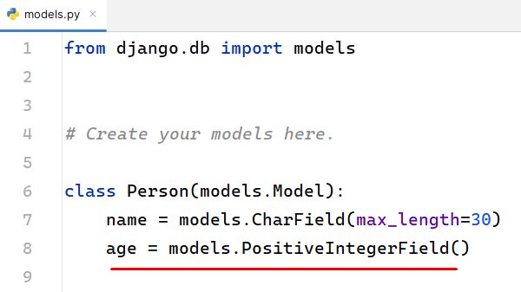
For our model to function properly, it is necessary to establish our database and implement migrations. To set up the database:
- Select the appropriate database for our needs, in this case, "PostgreSQL".
- Locate the "settings.py" file and navigate to the DATABASES dictionary.
- By default, the database is set to "sqlite3", which needs to be modified. Please refer to the provided link for detailed instructions on making the necessary changes.
In settings.py the default engine is sqlite3:
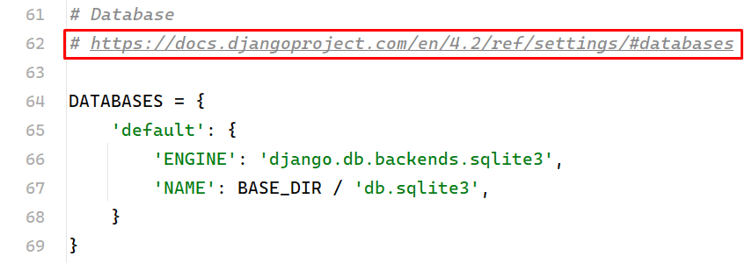
The PostgreSQL configuration should look like this:
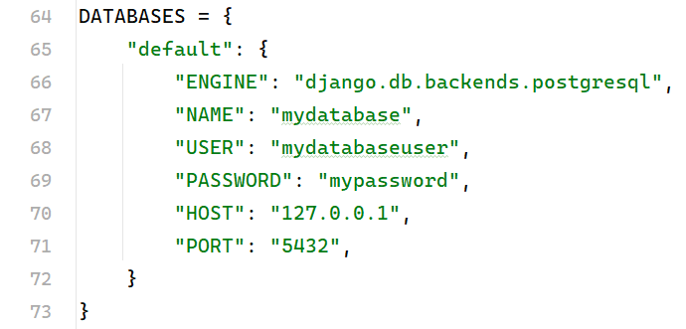
Note, it is necessary to edit the NAME, USER, and PASSWORD information with your personal!
To establish a server for the database, we can utilize PyCharm. Follow the steps below:
- In PyCharm, locate the top right corner of the screen and click on the "Database" option.
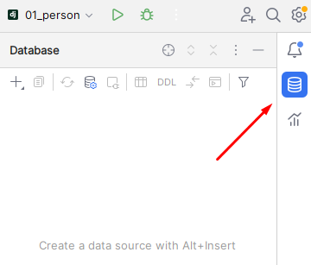
Click on Data Source and you will see a list of multiple data sources:
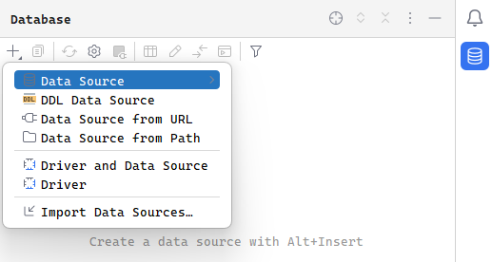
From the available options, select "PostgreSQL". Also, provide the necessary personal information and verify if the connection is successful.
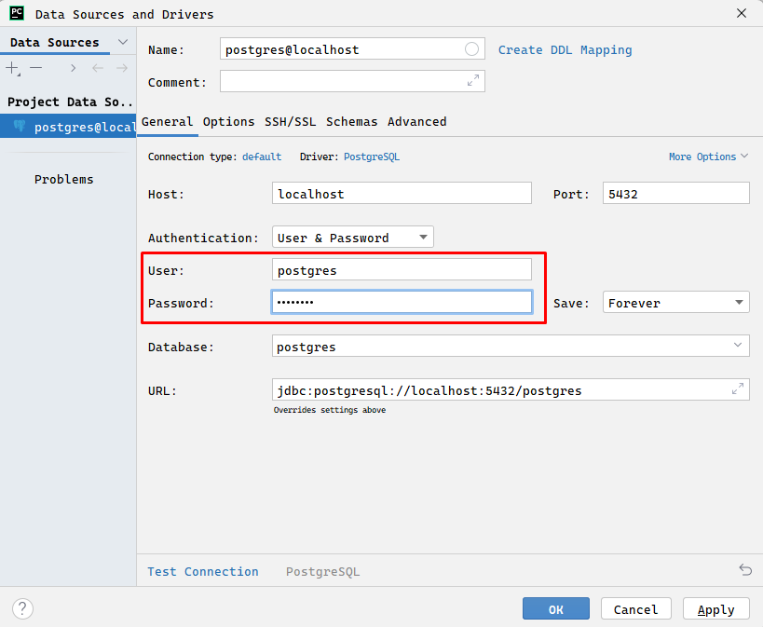

Now, let's create the actual database. First, Initialize the name of the database in "settings.py".
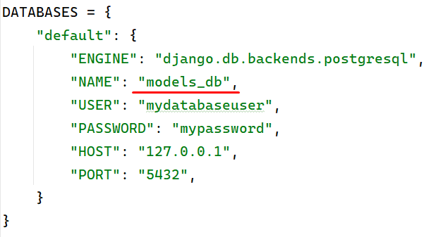
Then right-click on the server, select "Database," then choose "New" and assign a name to the database. For instance, we can name it "models_db".
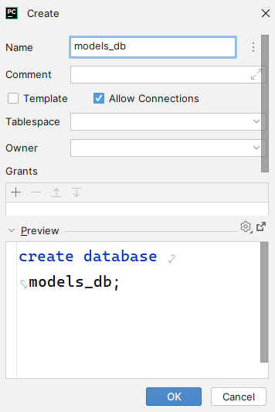
You will notice that PyCharm generates authentic SQL code, and you also have the option to write custom SQL queries. To ensure that the generated tables are visible later on, make the "public" schema visible:
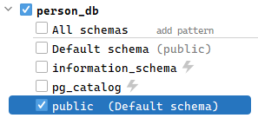
Remember to establish a connection between the database and the DATABASES dictionary in the "setings.py" file. Additionally, ensure that you provide your username and password as required.
Now, we are ready to apply some migrations.
When you first create the "Person" class and run the initial migration, Django will generate a migration file that represents the initial state of the "Person" model. This migration file contains instructions on how to create the corresponding database table and columns based on the model's fields ("name" and "age").
To manage migrations in Django, you can use two essential commands:
- "python manage.py makemigrations": This command is used to generate migration files based on the changes you've made to your models. It examines the differences between the current state of your models and the previous state recorded in existing migrations, creating new migration files to capture these changes.
- "python manage.py migrate": After using "makemigrations" to create migration files, you use this command to apply those migrations and update the database schema. It executes any pending migrations that haven't been applied to the database, keeping track of which migrations have already been applied to ensure only the necessary ones are executed.
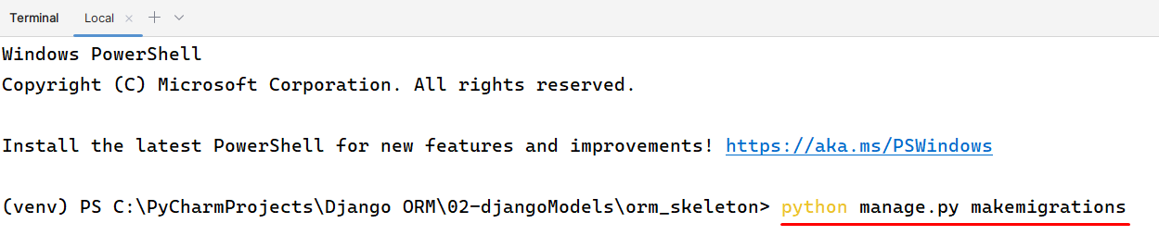
You will see an error like this:
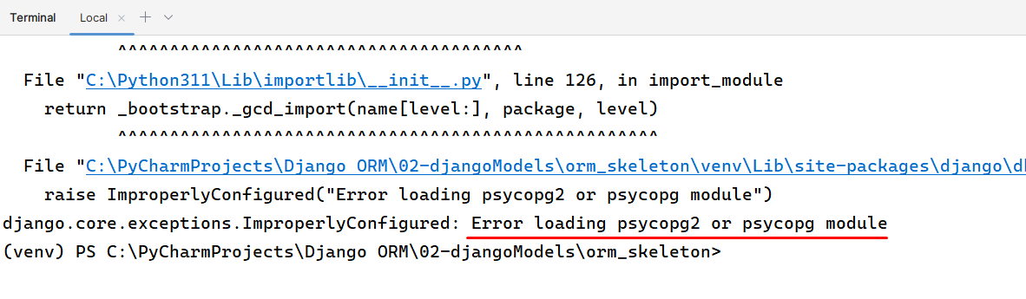
"Psycopg2" is a "PostgreSQL" adapter for Python, which allows Python programs to interact with a "PostgreSQL" database. To connect Django to the database we need to execute the following command:
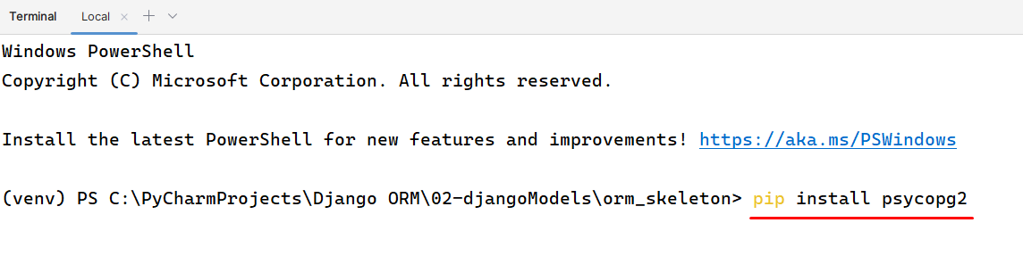
Finally, we can apply the migrations. They are created in the "migrations" folder inside its application. To transfer all the migrations to the database, we must run the command: "python manage.py migrate":
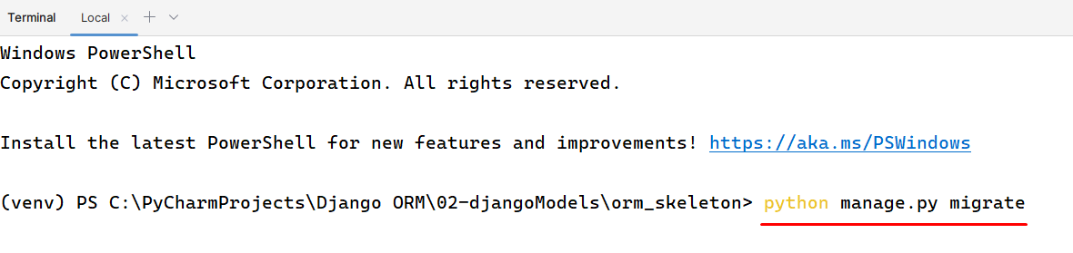
When you run the "migrate" command, Django reads the migration files and compares them with the current state of the database. It then determines which migrations need to be applied to bring the database schema up to date. After applying the command and reloading the database, inside the public schema, you can see several generated tables. They are the applied migrations:
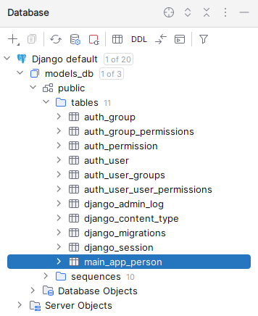
Upon selecting the "main_app_person" table, you will have visibility into all the stored data within it. At this point, we can proceed to create a new entity by adding a record with the name "Kaloyan" and the age "18". It's worth noting that the system will automatically generate the id field, ensuring a unique identifier for the new entry:
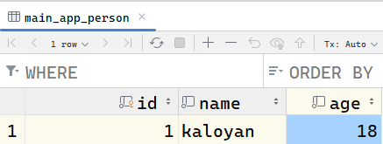

Blog
Write a Django model called "Blog" which stores information about the blog’s post and author:
- post
- Text field.
- author
- Character field.
- Every author has a length with a maximum of 35 characters.
After completing the model, you need to apply all changes (migrations) to the database.

Weather Forecast
Write a Django model called "WeatherForecast" with the following fields:
- date
- Date field.
- temperature
- Float field.
- humidity
- Float field.
- precipitation
- Float field.
After completing the model, you need to apply all changes (migrations) to the database.

Recipe
Write a Django model called "Recipe" with the provided information:
- name
- Character field.
- Every name has a length with a maximum of 100 characters.
- Also, each name must be unique.
- description
- Text field.
- ingredients
- Text field.
- cook_time
- Positive integer field.
- created_at
- Date time field.
- Every time a new record is created the current time of the creation of the record should be saved.

Product
Write a Django model called "Product" with the following fields:
- name
- Character field.
- Every name has a length with a maximum of 70 characters.
- description
- Text field.
- price
- Decimal field.
- Every price has a maximum of 10 digits and 2 decimal places.
- created_at
- Date time field.
- Every time a new record is created the current time of the creation of the record should be saved.

User Profile
Write a Django model called "UserProfile" with the following fields:
- username
- Character field.
- Each username has a length with a maximum of 65 characters.
- Also, make the username unique.
- first_name
- Character field.
- Each first_name has a length with a maximum of 40 characters.
- The first_name is not required.
- last_name
- Character field.
- Each last_name has a length with a maximum of 40 characters.
- The last_name is not required.
- email
- Email field.
- Each email is unique,
- Set a default value – "students@softuni.bg".
- bio
- Text field.
- Each bio has a length with a maximum of 120 characters.
- profile_image_url
- URL field.
- created_at
- Date time field.
- Every time a new record is created the current time of the creation of the record should be saved.

Exercise
Write a Django model called "Exercise" with the following fields:
- name
- Character field.
- Each name has a length with a maximum of 100 characters.
- description
- Text field.

- difficulty_level
- Character field.
- Each difficulty_level has a length with a maximum of 20 characters.
- duration_minutes
- Positive integer field.
- equipment
- Character field.
- Each "equipment" has a length with a maximum of 90 characters.
- video_url
- URL field.
- This field is not required.
- calories_burned
- Positive integer field.
- The field has a default value of 1.
- is_favorite
- Boolean field.
- The field has a default value of "False".

*Book [Solve with AI]
Write a Django model called "Book" with the following fields and register the model on the Django admin site.
- title
- Character field.
- Each title has a length with a maximum of 30 characters.
- author
- Character field.
- Each author has a length with a maximum of 100 characters.
- genre
- Character field.
- Each genre has a length with a maximum of 20 characters.
- The choices are – "Fiction", "Non-Fiction", "Science Fiction", and "Horror".
- publication_date
- Date field.
- The date should not be editable.
- Every time a new record is created the current time of the creation of the record should be saved.
- price
- Decimal field.
- Every price has a maximum of 8 digits and 2 decimal places.
- is_available
- Boolean field.
- The default value of the field is "True".
- rating
- Float field.
- description
- Text field.

Methods

__str__()
- The "__str__()" method should return the title as a single string.

Hint:
To get started, make sure to register your model in the "admin.py" file within the "main_app" application.
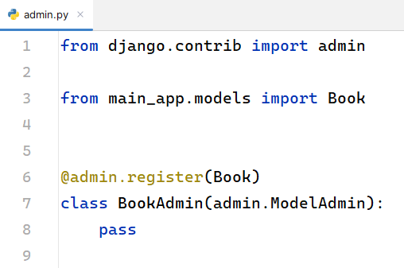
Then you need to run this command:
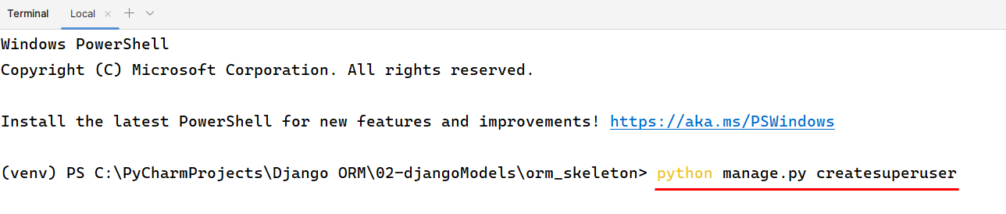
Executing this command will create a "super user" for the application. A super user has complete control over the CRUD operations within the application. Enter your preferred "username", "email", and "password", and you'll be able to access the following URL: http://127.0.0.1:8000/admin/login/?next=/admin/.
Once you've successfully logged in as the super user, you will assume the role of the application's "administrator":
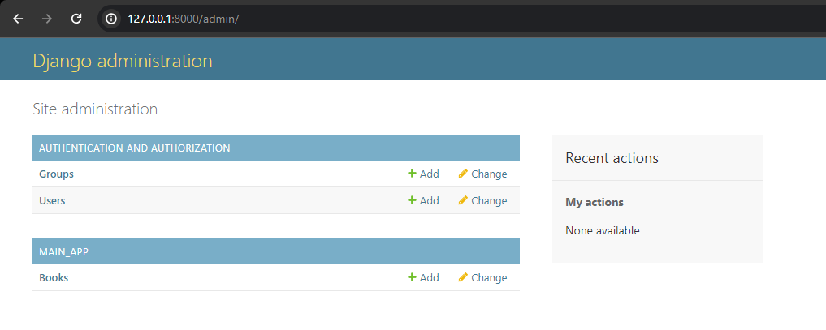
When an object is created the "__str__()" method will return the objects displayed with every book’s "title". As you can see, we are creating an object of the class "Book".
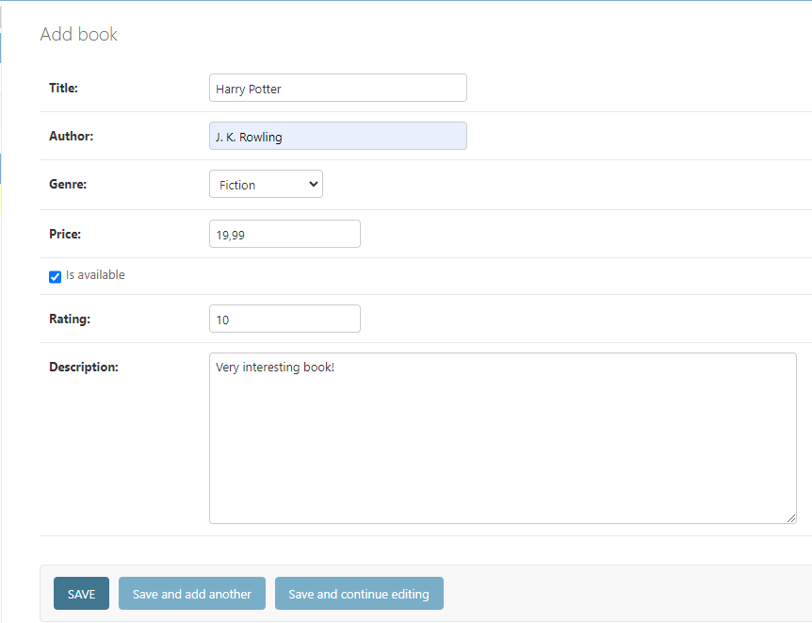
Every created object is displayed with the book’s title.
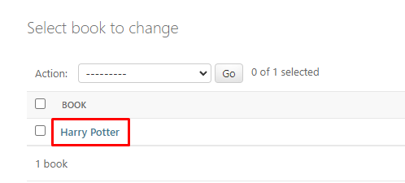
We'll explore advanced Django Admin Site customization in the upcoming exercise!

